Step1: S3 bucket is created

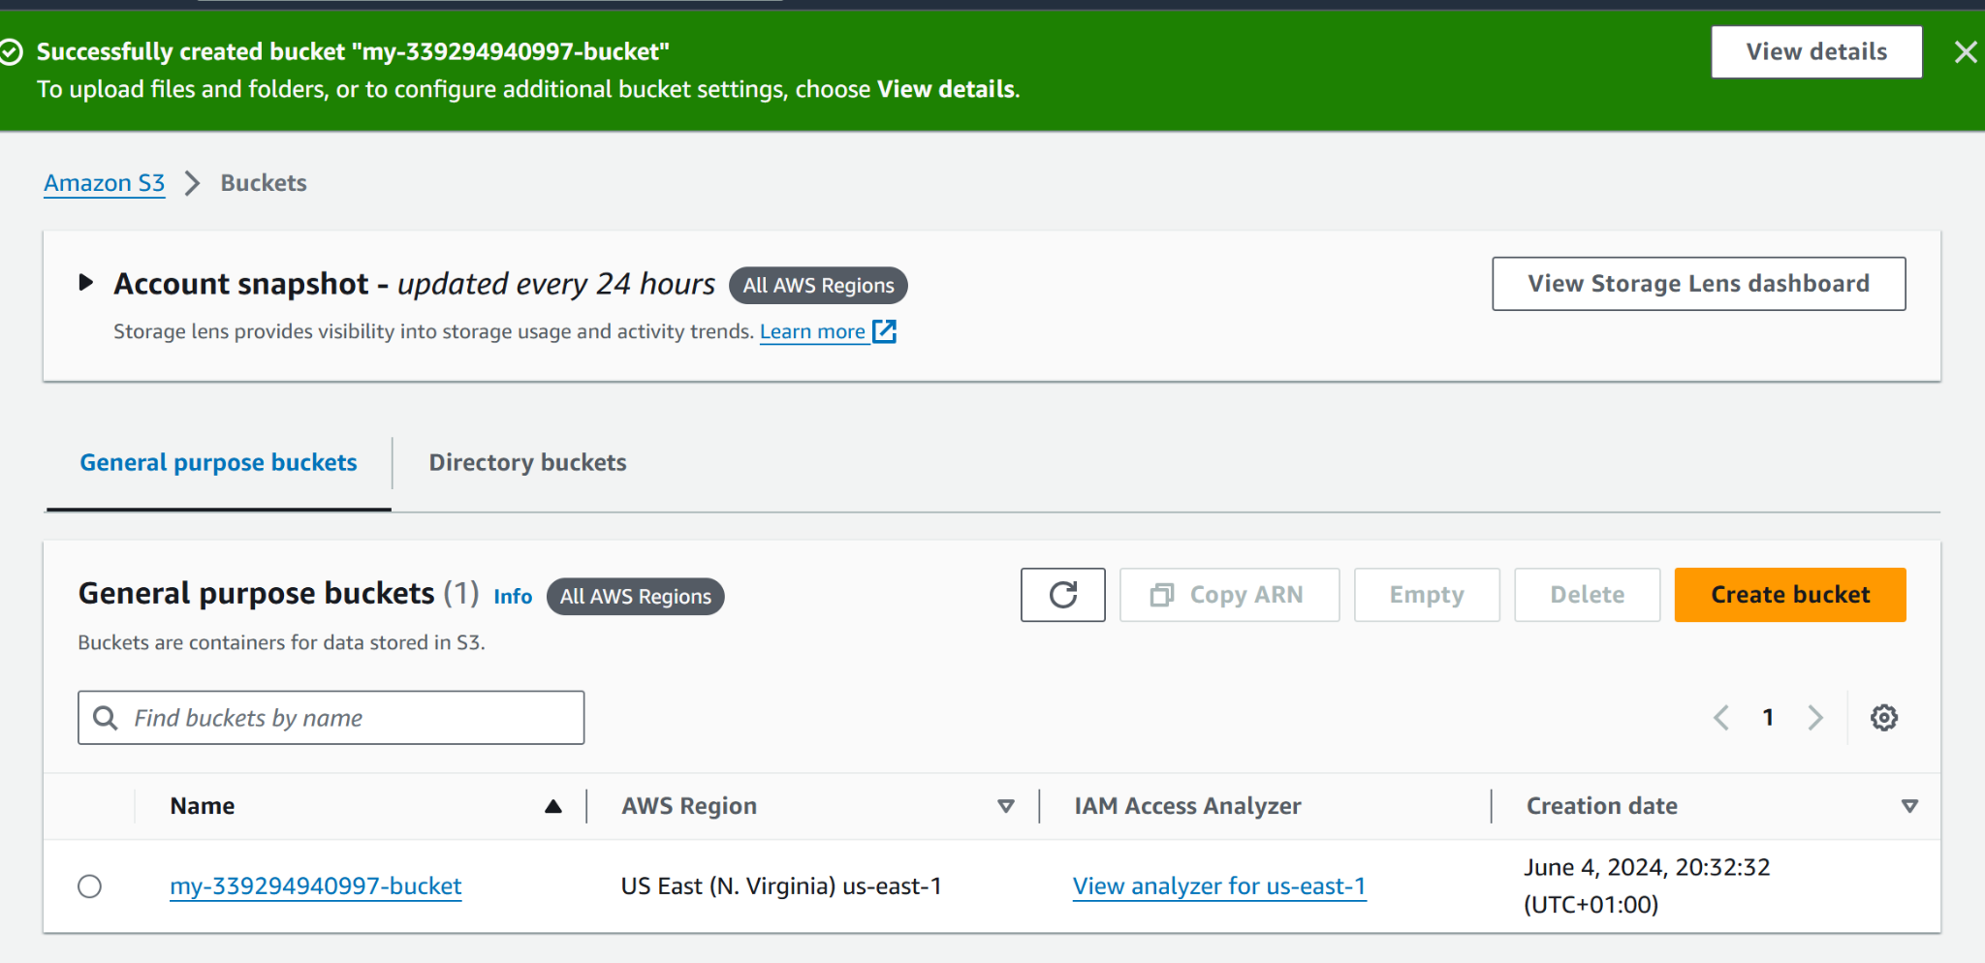

Step2: The static website related files & folders have been uploaded to the bucket

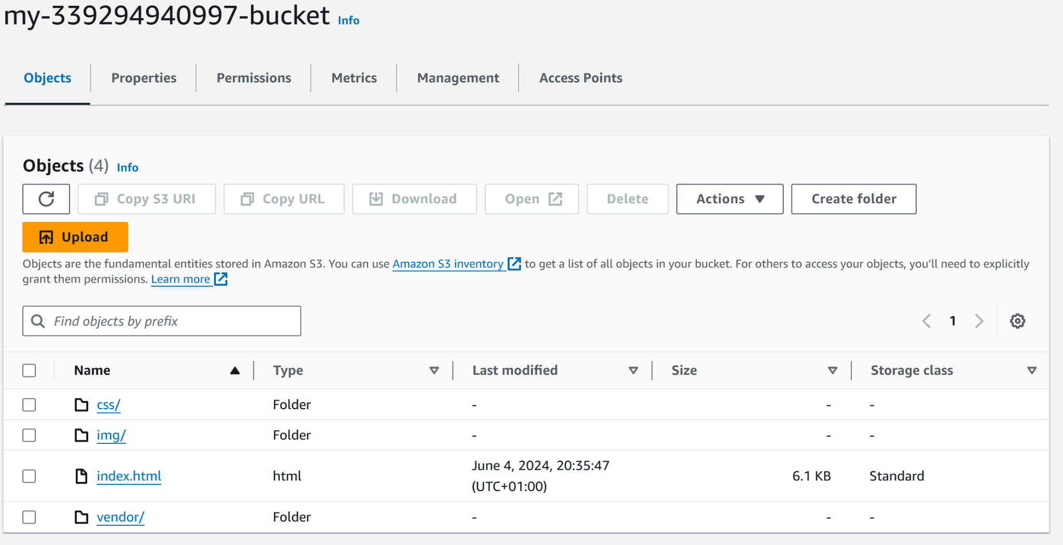

Step3: S3 Bucket has been configured for static website hosting. Endpoint shared in screenshot below:

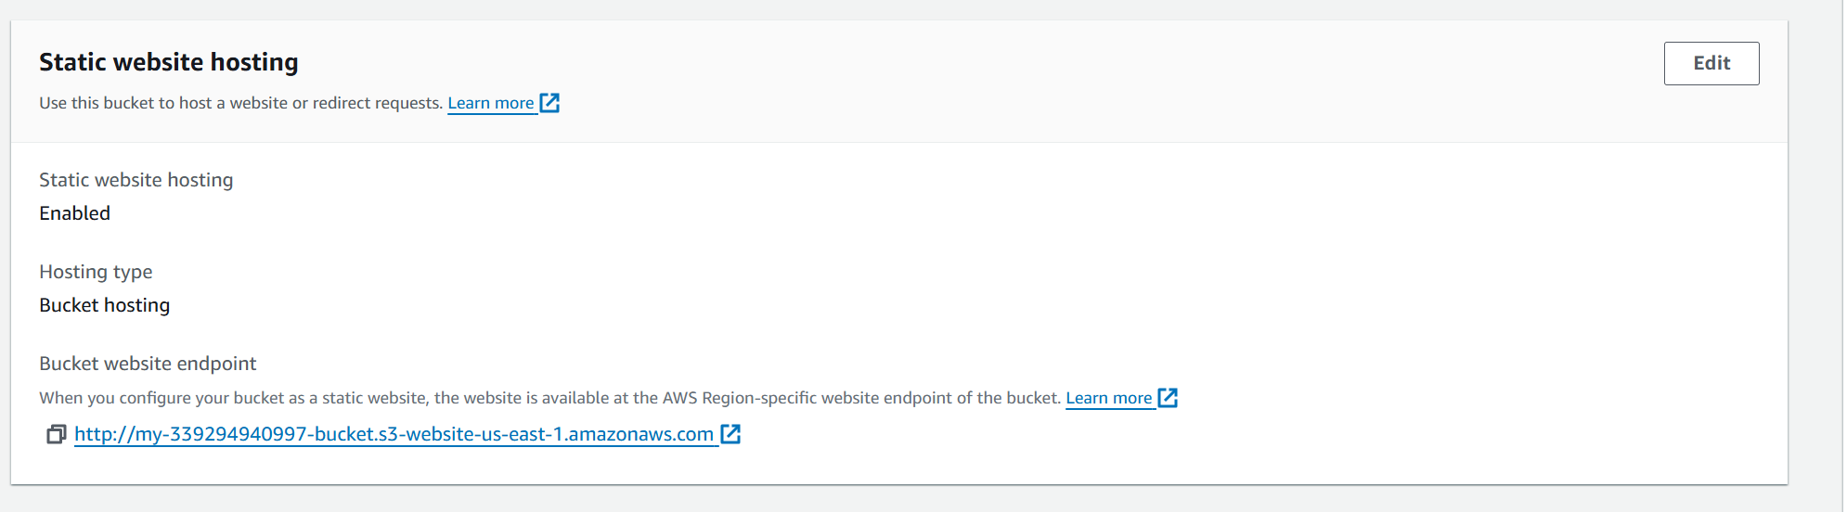

Step4: S3 Bucket IAM Policy & Permissions (Screenshot taken After CloudFront Distribution):

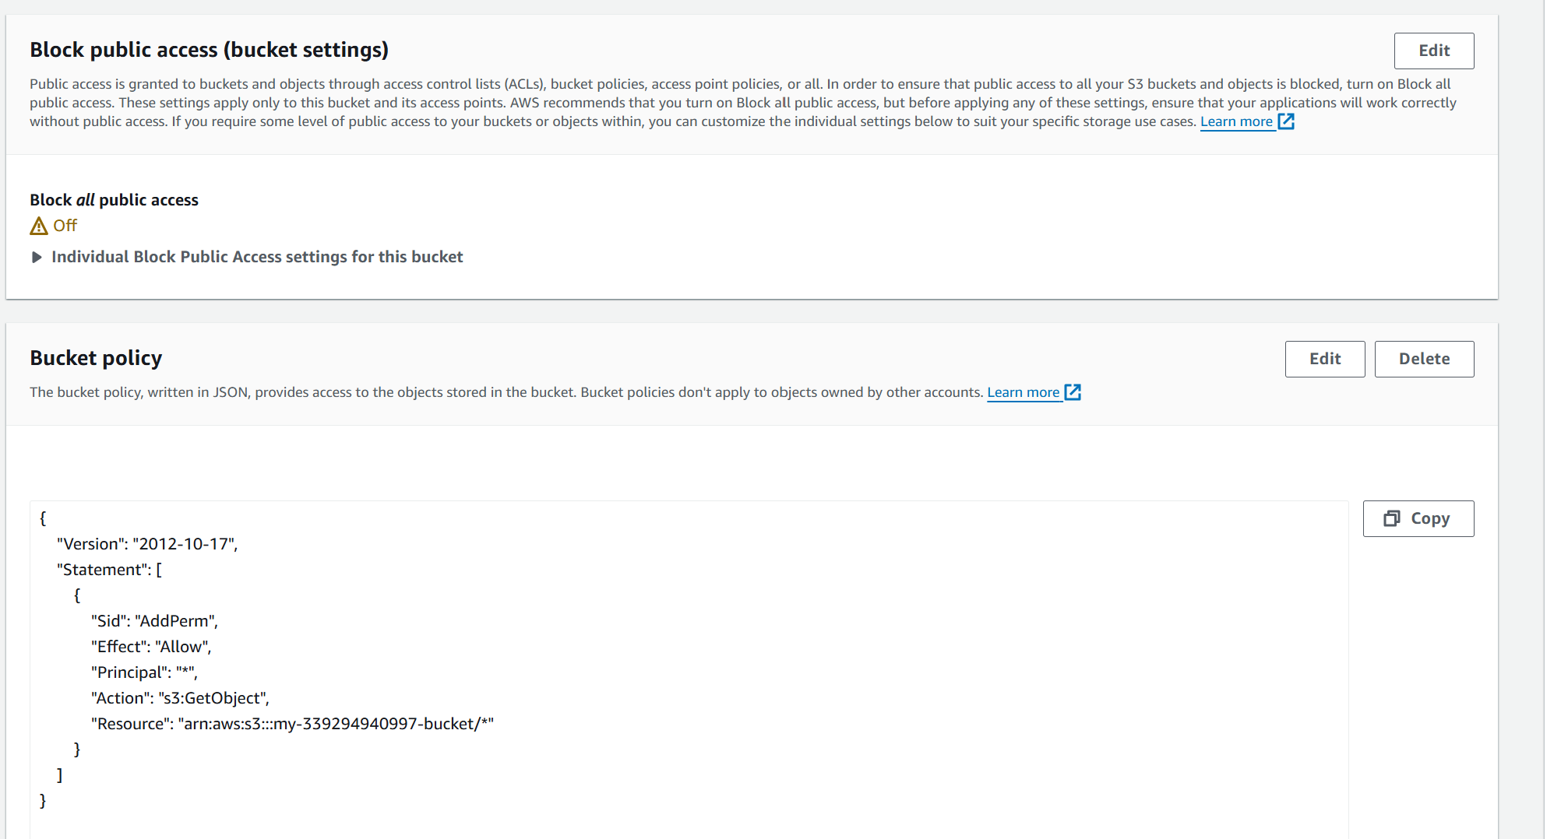

Step5: Cloudfront has been created :

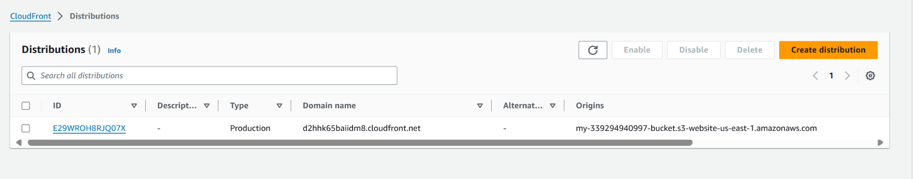

Step6: Cloudfront configuration with domain name

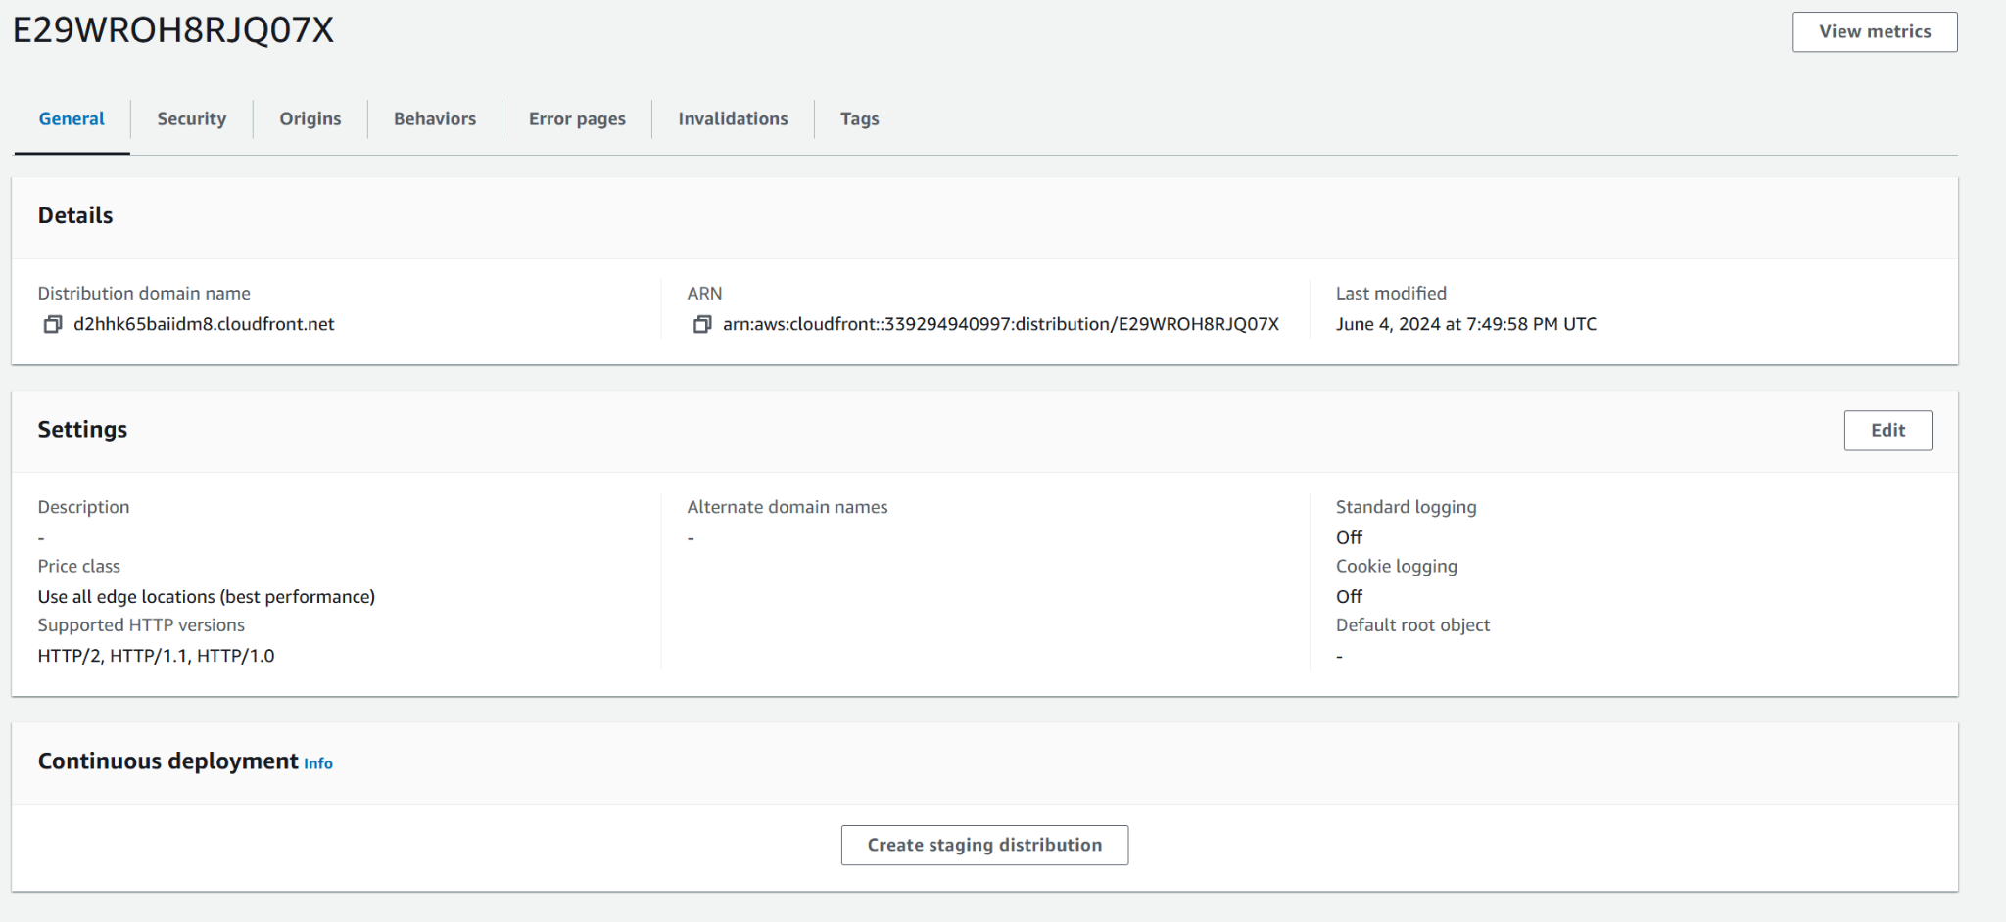

Step7: Web Browser Access 



